**Service Monitoring – Hystrix, Eureka admin and Spring boot admin**

Spring boot and spring cloud are widely used while delivering microservices-based applications. Eventually, it has become a necessity to **monitor microservices** based on Spring boot applications running on different hosts. There are many tools available to monitor various health stats of these microservices.

In this *spring cloud tutorial*, we will learn to use three such monitoring tools i.e. **Hystrix dashboard**, **Eureka admin dashboard** and **Spring boot admin dashboard**.

Table of Contents

[1. Overview](https://howtodoinjava.com/spring-cloud/microservices-monitoring/#overview)

[2. Technology stack](https://howtodoinjava.com/spring-cloud/microservices-monitoring/#techstack)

[3. Employee Service](https://howtodoinjava.com/spring-cloud/microservices-monitoring/#employeeservice)

[4. API-Gateway application](https://howtodoinjava.com/spring-cloud/microservices-monitoring/#apigateway)

[5. Hystrix dashboard view](https://howtodoinjava.com/spring-cloud/microservices-monitoring/#hystrix-dashboard)

[6. Eureka admin dashboard view](https://howtodoinjava.com/spring-cloud/microservices-monitoring/#eureka-dashboard)

[7. Spring boot admin dashboard view](https://howtodoinjava.com/spring-cloud/microservices-monitoring/#boot-admin-dashboard)

**1. Overview**

In this demo, we will *create three applications*.

1. **Employee Service** – This microservice application is responsible to fetch data of Employees.
2. **Api-Gateway** – This application is to provide common gateway while accessing different microservices. In the following example it will act as a gateway to Employee Service above.
3. **Eureka Server** – This microservice application will provide service discovery and registration of above microservices.

This demo has been created around **Netflix Eureka** to centrally manage and monitor registered applications. As you may already know that Netflix Eureka server is for building **service registry server** and associated Eureka clients, which will register themselves to lookup other services and communicate through REST apis.

**3. Employee Service**

* Create a Spring boot project from [Spring boot initializer](https://start.spring.io/)/[Spring tool suite](https://spring.io/tools/sts) with dependencies **Eureka Discovery**, **Actuator**, **Web**, **Rest repositories**.

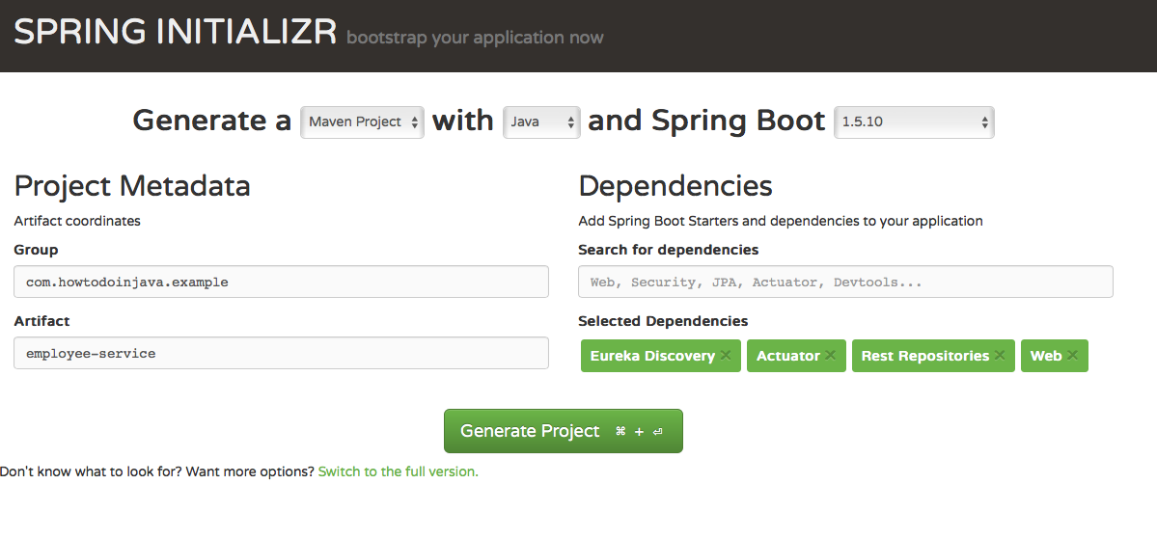

* The main application class EmployeeServiceApplication to start the Spring boot application.

|  |
| --- |
| EmployeeServiceApplication.java |
| package com.howtodoinjava.example.employee;  import org.springframework.boot.SpringApplication;  import org.springframework.boot.autoconfigure.SpringBootApplication;  import org.springframework.cloud.netflix.eureka.EnableEurekaClient;    @SpringBootApplication  @EnableEurekaClient  public class EmployeeServiceApplication {      public static void main(String[] args)    {      SpringApplication.run(EmployeeServiceApplication.class, args);    }  } |

* **@EnableEurekaClient** – This annotation register this service as an Eureka client in [Eureka Server application](https://howtodoinjava.com/spring-cloud/microservices-monitoring/#eureka-dashboard) created below.
* Create a Rest controller class [*EmployeeServiceController*] to expose Employee data.

|  |
| --- |
| EmployeeServiceController.java |
| package com.howtodoinjava.example.employee.controller;    import java.util.HashMap;  import java.util.Map;    import org.springframework.web.bind.annotation.PathVariable;  import org.springframework.web.bind.annotation.RequestMapping;  import org.springframework.web.bind.annotation.RequestMethod;  import org.springframework.web.bind.annotation.RestController;    import com.howtodoinjava.example.employee.beans.Employee;    @RestController  public class EmployeeServiceController {          private static final Map<Integer, Employee> employeeData = new HashMap<Integer,Employee() {            private static final long serialVersionUID = -3970206781360313502L;          {              put(111,new Employee(111,"Employee1"));              put(222,new Employee(222,"Employee2"));          }      };        @RequestMapping(value = "/findEmployeeDetails/{employeeId}", method = RequestMethod.GET)      public Employee getEmployeeDetails(@PathVariable int employeeId) {          System.out.println("Getting Employee details for " + employeeId);            Employee employee = employeeData.get(employeeId);          if (employee == null) {                employee = new Employee(0, "N/A");          }          return employee;      }  } |

* Associated Employee Bean class is below.

|  |
| --- |
| Employee.java |
| package com.howtodoinjava.example.employee.beans;    public class Employee {        private String name;      private int id;        @Override      public String toString() {          return "Employee [name=" + name + ", id=" + id + "]";      }  } |

* Create application.yml in src/main/resources directory.

|  |
| --- |
| application.yml |
| server:    port: 8011    eureka:    instance:      leaseRenewalIntervalInSeconds: 5      leaseExpirationDurationInSeconds: 2    client:      serviceUrl:        defaultZone: http://localhost:8761/eureka/      healthcheck:        enabled: true      lease:        duration: 5    spring:    application:      name: employee-service    management:    security:      enabled: false    logging:    level:      com.self.sprintboot.learning.employee: DEBUG |

* Start this application reachable http://localhost:8011/findEmployeeDetails/111  
  https://howtodoinjava.com/wp-content/uploads/2018/03/Screen-Shot-2018-03-10-at-5.26.43-PM.png

**4. API-Gateway with Hystrix**

* Create a Spring boot project from [Spring boot initializer](https://start.spring.io/)/[Spring tool suite](https://spring.io/tools/sts) with dependencies Eureka Discovery, Actuator, Web, Hystrix, Hystrix Dashboard, Rest repositories.

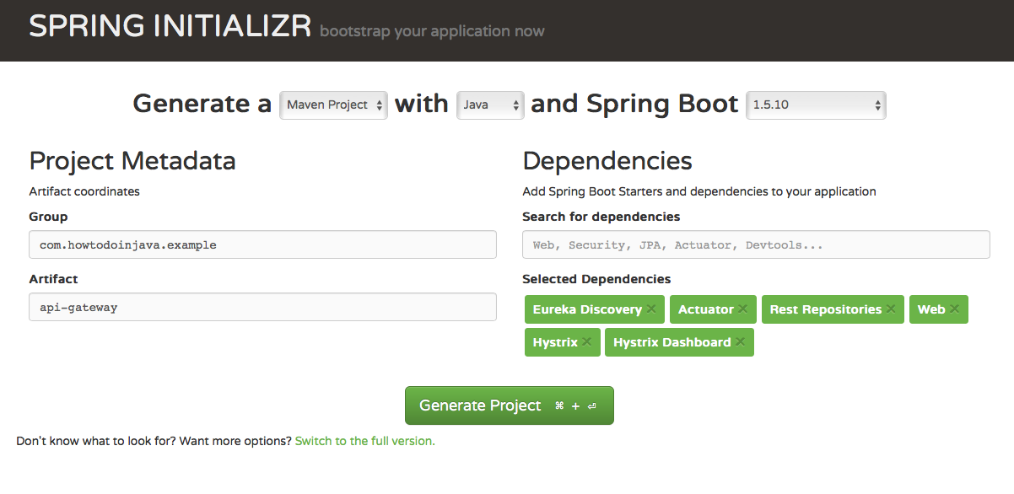

* The main application class ApiGatewayApplication to start Spring boot application.

|  |
| --- |
| ApiGatewayApplication.java |
| package com.howtodoinjava.example.apigateway;    import org.springframework.boot.SpringApplication;  import org.springframework.boot.autoconfigure.SpringBootApplication;  import org.springframework.cloud.client.circuitbreaker.EnableCircuitBreaker;  import org.springframework.cloud.netflix.eureka.EnableEurekaClient;  import org.springframework.cloud.netflix.hystrix.dashboard.EnableHystrixDashboard;    @SpringBootApplication  @EnableEurekaClient  @EnableHystrixDashboard  @EnableCircuitBreaker  public class ApiGatewayApplication {        public static void main(String[] args) {          SpringApplication.run(ApiGatewayApplication.class, args);      }  } |

* **@EnableHystrixDashBoard** – To give dashboard view of Hystrix stream.  
  **@EnableCircuitBreaker** – To enable Circuit breaker implementation.
* Create a REST controller class [*EmployeeController*] to expose Employee data.

|  |
| --- |
| EmployeeController.java |
| package com.howtodoinjava.example.apigateway.controller;    import org.springframework.beans.factory.annotation.Autowired;  import org.springframework.cloud.client.loadbalancer.LoadBalanced;  import org.springframework.context.annotation.Bean;  import org.springframework.core.ParameterizedTypeReference;  import org.springframework.http.HttpMethod;  import org.springframework.web.bind.annotation.PathVariable;  import org.springframework.web.bind.annotation.RequestMapping;  import org.springframework.web.bind.annotation.RequestMethod;  import org.springframework.web.bind.annotation.RestController;  import org.springframework.web.client.RestTemplate;    import com.netflix.hystrix.contrib.javanica.annotation.HystrixCommand;    @RestController  public class EmployeeController {        @Autowired      RestTemplate restTemplate;        @RequestMapping(value = "/employeeDetails/{employeeid}", method = RequestMethod.GET)      @HystrixCommand(fallbackMethod = "fallbackMethod")      public String getStudents(@PathVariable int employeeid)      {          System.out.println("Getting Employee details for " + employeeid);            String response = restTemplate.exchange("<http://employee-service/findEmployeeDetails/>{employeeid}",                                  HttpMethod.GET, null, new ParameterizedTypeReference<String>() {}, employeeid).getBody();            System.out.println("Response Body " + response);            return "Employee Id -  " + employeeid + " [ Employee Details " + response+" ]";      }        public String  fallbackMethod(int employeeid){            return "Fallback response:: No employee details available temporarily";      }        @Bean      @LoadBalanced      public RestTemplate restTemplate() {          return new RestTemplate();      }  } |

* Create application.yml in src/main/resources directory.

|  |
| --- |
| application.yml |
| server:    port: 8010    #port number    eureka:    instance:      leaseRenewalIntervalInSeconds: 5      leaseExpirationDurationInSeconds: 2    client:      serviceUrl:        defaultZone: http://localhost:8761/eureka/      healthcheck:        enabled: true      lease:        duration: 5    spring:    application:      name: api-gateway    management:    security:      enabled: false    logging:    level:      com.self.sprintboot.learning.apigateway: DEBUG |

* Start the application reachable at http://localhost:8010/employeeDetails/111.

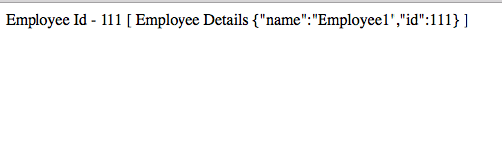

**5. Hystrix dashboard view**

* To **monitor via Hystrix dashboard**, open Hystrix dashboard at http://localhost:8010/hystrix.

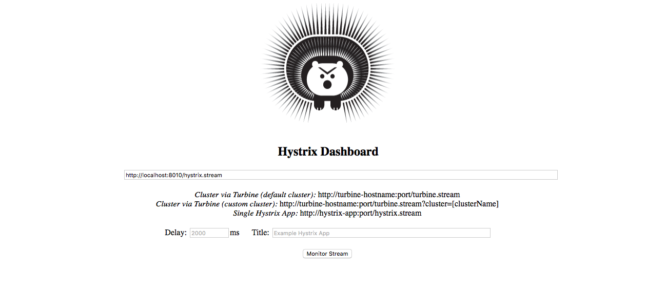

This is the home page where event stream URL needs to be put for monitoring.

* Now view **hystrix stream** in dashboard – http://localhost:8010/hystrix.stream

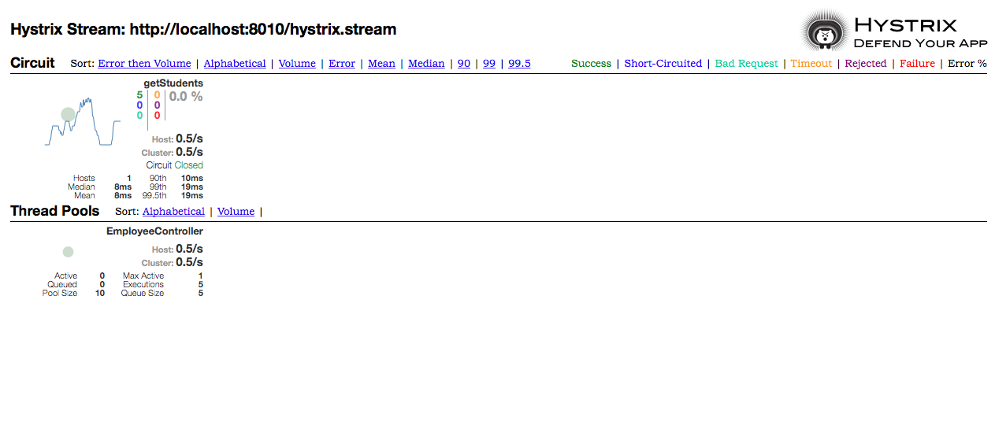

This provides realtime information of all Hystrix commands and thread pools.

**6. Eureka admin dashboard view**

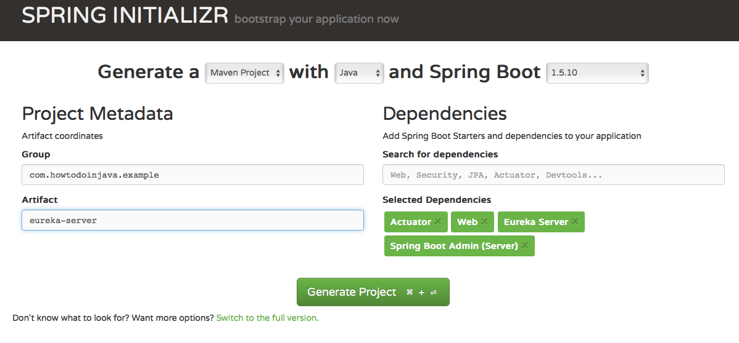

* The main application class EurekaServerApplication to start spring boot application.

|  |
| --- |
| EurekaServerApplication.java |
| package com.howtodoinjava.example.eureka;    import org.springframework.boot.SpringApplication;  import org.springframework.boot.autoconfigure.SpringBootApplication;  import org.springframework.cloud.netflix.eureka.server.EnableEurekaServer;    import de.codecentric.boot.admin.config.EnableAdminServer;    @SpringBootApplication  @EnableEurekaServer  @EnableAdminServer    public class EurekaServerApplication {        public static void main(String[] args) {          SpringApplication.run(EurekaServerApplication.class, args);      }  } |

* **@EnableEurekaServer**– This annotation will make this application to act as Microservice registry and discovery server.  
  **@EnableAdminServer**– This annotation provides Spring Boot Admin configuration.
* Create application.yml and bootstrap.yml in src/main/resources directory.
* Add application.yml with given config. Please note that for Spring boot admin server a different context path /admin has been provided for not conflicting with /eureka.

|  |
| --- |
| application.yml |
| server:    port: ${PORT:8761}    eureka:    client:      registryFetchIntervalSeconds: 5      registerWithEureka: false      serviceUrl:        defaultZone: ${DISCOVERY_URL:http://localhost:8761}/eureka/    instance:      leaseRenewalIntervalInSeconds: 10    management:    security:      enabled: false  spring:    boot:      admin:        context-path: /admin  #A different context path for Spring boot admin server has been provided avoiding conflict with eureka |

* Create bootstrap.yml and give this configuration.

|  |
| --- |
| bootstrap.yml |
| spring:    application:      name: Eureka-Server    cloud:      config:        uri: ${CONFIG_SERVER_URL:http://localhost:8888} |

* Start the application. But before that make sure the rest of the client applications mentioned above are started before so as to see all registered applications. This application is reachable at http://localhost:8761.

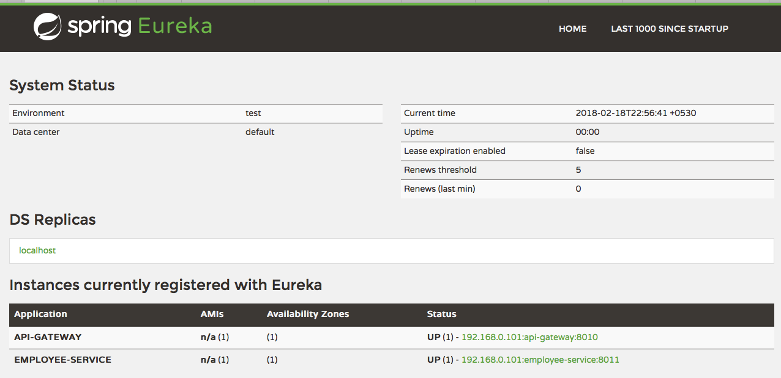

**7. Spring boot admin dashboard view**

* To monitor via Spring Boot Admin server, invoke this URL running at different context path- http://localhost:8761/admin.

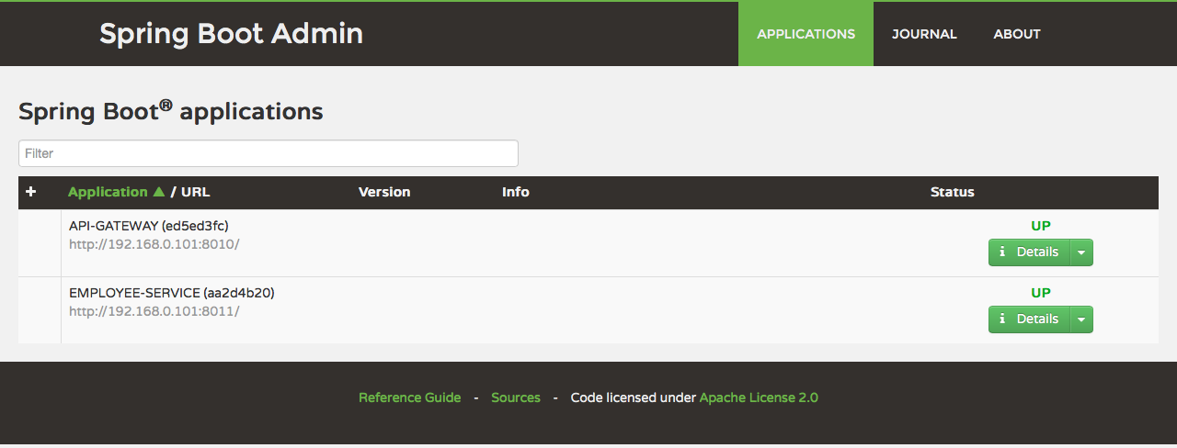

* This admin interface provides application overview, desktop notifications, application health check, log file browsing, JMX Beans, thread heap dump etc. To see individual application health and monitor its metrics, click on the detail button. It will take you to the admin dashboard of individual application.

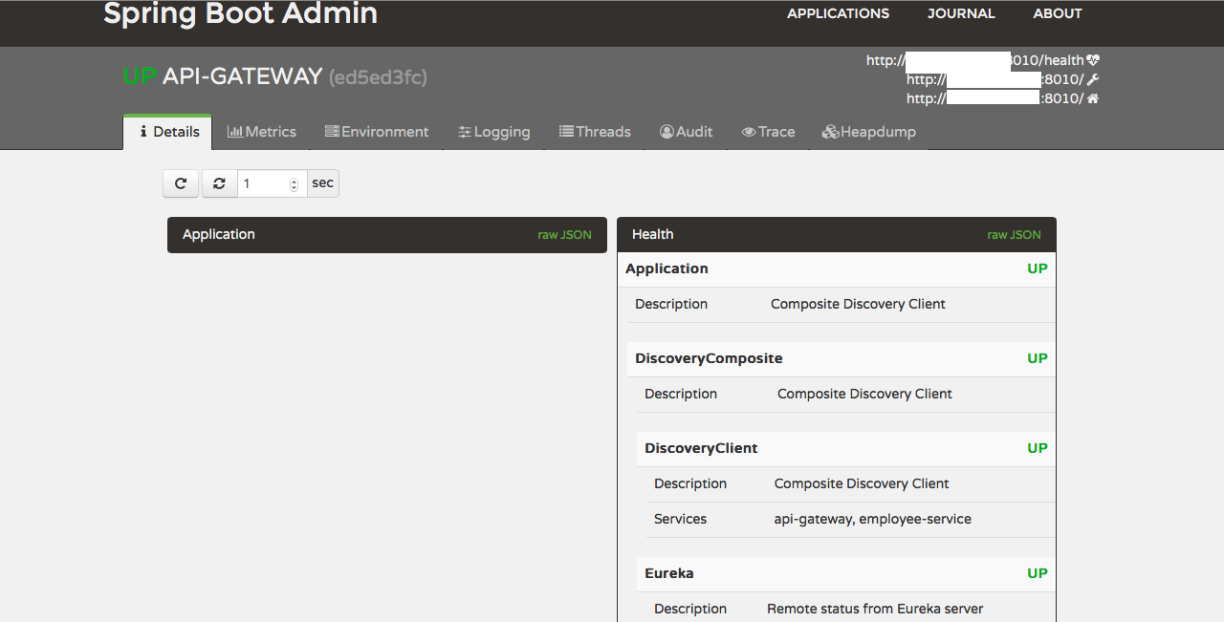

* Using dashboard to manage log levels.  
  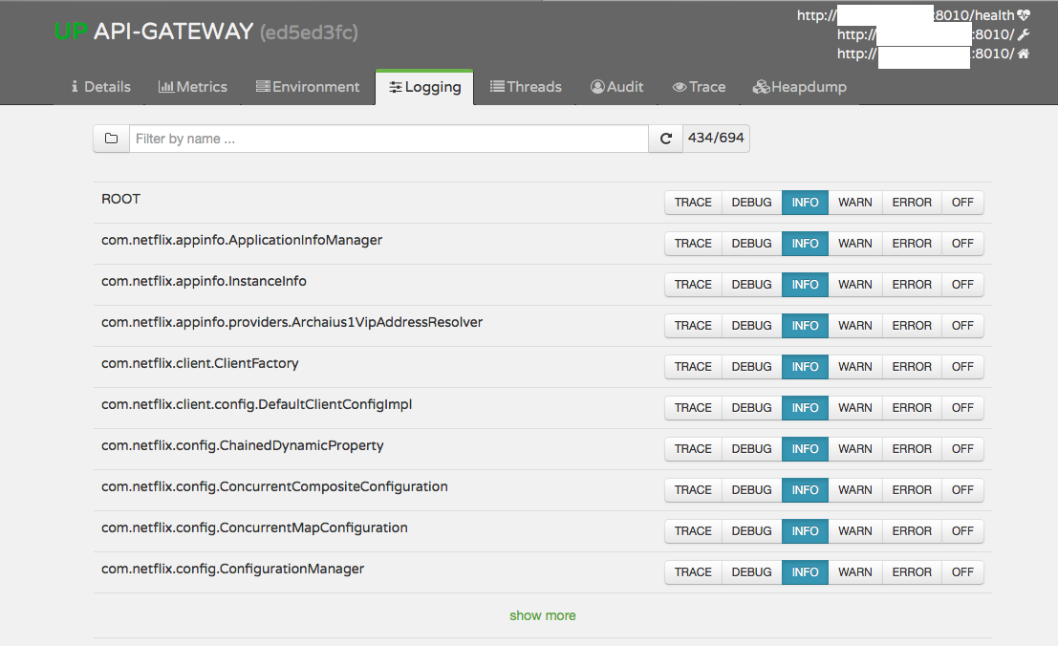
* Using dashboard to manage runtime environment properties.

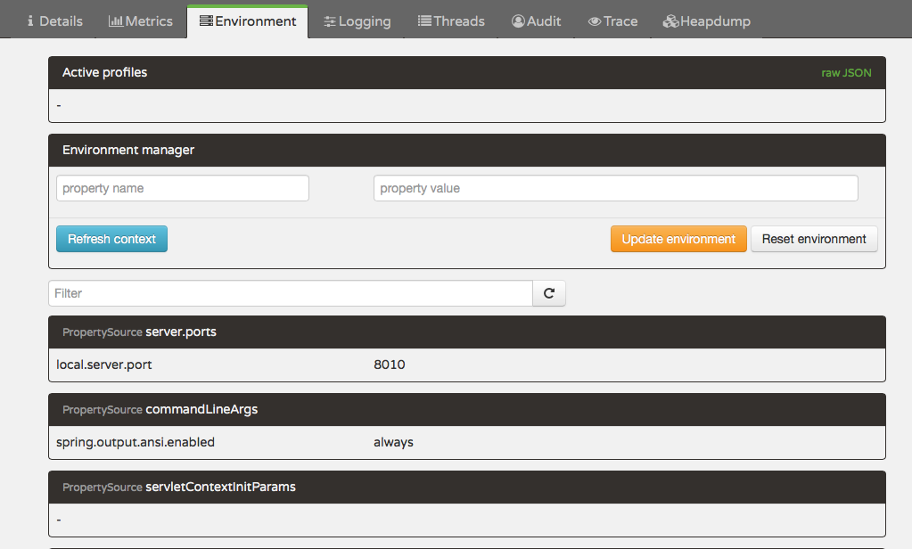

* Also you can use it to view HTTP traces.

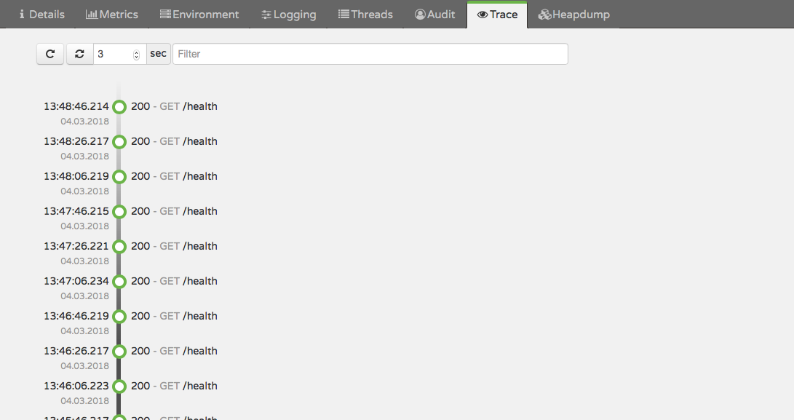

I downloaded all three applications and executed them.  
But,  
<http://localhost:8010/employeeDetails/111>  
does not give the result. It always call the fallback method.  
Please try once and see.  
Narayan Khanna